**A**

**Project Report**

on

“APPLICATIONS OF DISCRETE MATHEMATICS IN CSE”

**Submitted by**

by

#### Sumeet P Bafna (USN: 2GI19CS157)

#### Venkatesh Dhongadi (USN: 2GI19CS175)

#### Vivek Jadhav (USN: 2GI19CS185)

#### Vivek Valagadde (USN: 2GI19CS186)



Department of Mathematics Department

KLS Gogte Institute of Technology,

Udyambag, Belgaum - 590008, Karnataka, India

**ABSTRACT :**

The main aim of this paper is to lay stress on the role of Discrete Structures or Discrete Mathematics in various disciplines. We all know that this theory is of great importance in natural sciences as well as in engineering. The solution of various engineering problems can be obtained with the help of Discrete Mathematics. It is one of the most useful tools for an engineer or a scientist for solving and analyzing real world problems like for understanding algorithms, creating logical solutions in programming or software system design specifications, etc. In this paper we are going to discuss general frame work of Discrete Mathematics with some existing examples

**INTRODUCTION :**

Discrete Mathematics is the study of mathematical structures that are fundamentally discrete rather than continuous. In contrast to real numbers that have the property of varying "smoothly", the objects studied in Discrete Mathematics – such as integers, graphs, and statements in logic do not vary smoothly in this way, but have distinct, separated values. Discrete mathematics therefore

excludes topics in "Continuous Mathematics" such as calculus and analysis. Discrete objects can

often be enumerated by integers. More formally, Discrete Mathematics has been characterized as

the branch of mathematics dealing with countable sets (sets that have the same cardinality as

subsets of the natural numbers, including rational numbers but not real numbers). However, there is no exact, universally agreed, definition of the term "Discrete Mathematics”.

**IMPORTANCE OF DISCRETE MATHEMATICS:**

Achieving working knowledge of many principles of computer science requires mastery of certain

relevant mathematical concepts and skills. For example, A grasp of Boolean algebra including De-

Morgan’s Law is useful for understanding Boolean expressions and the basics of combinational

circuits concepts surrounding the growth of functions and summations are useful for analysis of

loop control structures exposure to solving recurrence relations is de-rigueur for the analysis of recursive algorithms and an introduction to proof methods facilitates consideration of program

correctness and thinking rigorously in general.

Researcher and Students are introduced to proof techniques before they begin to consider the idea

of proving programs correct through the study of discrete structure. They learn about propositional

logic and Boolean algebra before they study some very elementary circuits and learn decision

control structures and Boolean variables. They are introduced to predicate logic near the time they

are beginning programming and learning about variables. They learn about growth of functions

big-O notation and summations before they analyse loops and nested loops and they have the tools to begin algorithm analysis from the time they first begin to learn about iterative constructs. In conjunction with an introduction to number theory they do laboratory and programming exercises involving an assortment of integer algorithms.

Thus we learn about recursive definitions recurrence relations, analysing recursive algorithms and

writing recursive algorithms and programs together in the same course of discrete structure. We

study matrices and matrix manipulations in conjunction with the array data structure and learn

about permutations and combinations, relations, graphs, and trees at the same time our

programming knowledge and sophistication are improving and this help us to do increasingly interesting programming exercises involving above concepts of mathematics.

**APPLICATIONS OF DISCRETE MATHEMATICS:**

1. **Theoretical Computer Science :**

Theoretical computer science includes areas of discrete mathematics relevant to computing. It

draws heavily on graph theory and logic. Included within theoretical computer science is the study

of algorithms for computing mathematical results. Computability studies what can be computed in

principle, and has close ties to logic, while complexity studies the time taken by computations.

Automata theory and formal language theory are closely related to computability. Petri nets and

process algebras are used to model computer systems, and methods from discrete mathematics are used in analyzing VLSI electronic circuits. Computational geometry applies algorithms to

geometrical problems, while computer image analysis applies them to representations of images.

Theoretical computer science also includes the study of various continuous computational topics.

**2) Information-Theory:**

Information theory involves the quantification of information. Closely related is coding theory

which is used to design efficient and reliable data transmission and storage methods. Information

theory also includes continuous topics such as analog signals, analog coding, analog encryption and

Mathematical logic.

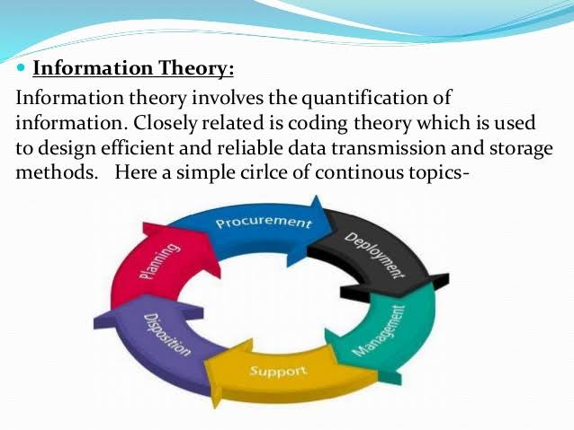

**3) Mathematical logic:**

Logic is the study of the principles of valid reasoning soundness and completeness. For example, in most Peirce's law ( ( ( P-> Q ) -> P ) -> P ) is a theorem. For truth table. The study of mathematical proof is particularly to automated theorem proving and formal verification

**4) Set theory :**

Set theory is the branch of mathematics that studies {blue, white, and red} or the (infinite) set of all prime other relations have applications in several areas. and inference, as well as of consistency,

systems of logic (but not in intuitionistic logic) classical logic, it can be easily verified with a

important in logic and has applications of software. sets, which are collections of objects, such as

numbers. Partially ordered sets and sets with In Discrete Mathematics, countable sets (including finite sets) are the main focus. The beginning of set theory as a branch of mathematics is usually marked by Georg Cantor's work distinguishing between different kinds of infinite set, motivated by the study of trigonometric series, and further development of the theory of infinite sets is outside the scope of discrete mathematics. Indeed, contemporary work in descriptive set theory makes extensive use of traditional continuous mathematics.

**5) Graph theory :**

Graph theory, the study of graphs and networks, but has grown large enough and distinct enough,

with its own kind of problems, to be regarded as a subject in its own right. Graphs are one of the

prime objects of study in discrete mathematics. They are among the most ubiquitous models of

both natural and human-made structures. They can model many types of relations and process

dynamics in physical, biological and social systems. In computer science, they can represent

networks of communication, data organization, computational devices, the flow of computation**.**

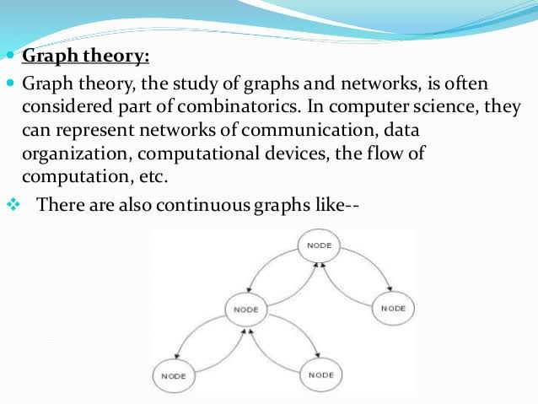

**6) Trees:**

Trees are used to represent data that has some hierarchical relationship among the data elements

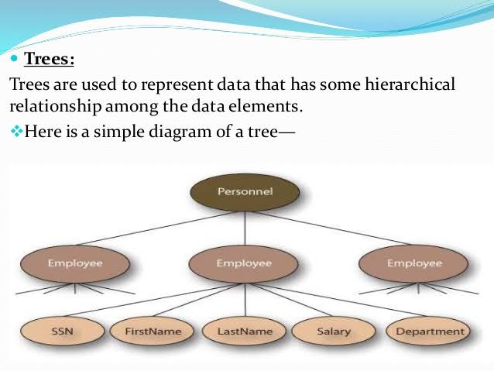

**7) Topology:**

Although topology is the field of mathematics that formalizes and generalizes the intuitive notion

of "continuous deformation" of objects, it gives rise to many discrete topics; this can be attributed

in part to the focus on topological invariants, which themselves usually take discrete values. See

combinatorial topology, topological graph theory, topological combinatorics, computational topology, discrete topological space, finite topological space, topology (chemistry).

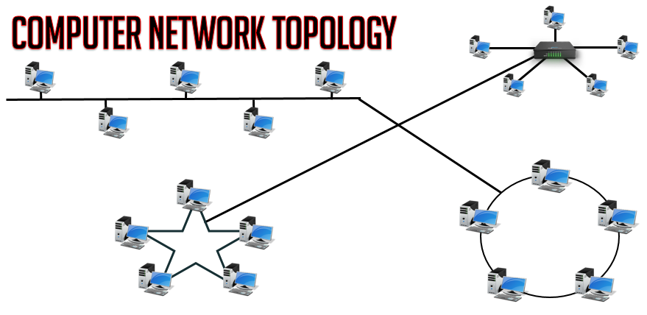

**CONCLUSION :**

We emphasize the essential role that Discrete Mathematics plays in the development of computer

science both for the practical knowledge and for the reasoning skills associated with mathematical

maturity. This paper lays stress on the importance of certain mathematical concepts for computer

science. Hence present a comprehensive table of Discrete Structure and its applications in

computer science engineering.

**REFERENCES :**

* Balakrishnan R. and Ranganathan K. (2012). A Textbook of Graph Theory. Springer, Berlin,

http://dx.doi.org/10.1007/978-1-4614-4529-6.

* LOVÁSZ L, PELIKÁN P, VESZTERGOMBI K, (2003). A BOOK TITLED “DISCRETE MATHEMATICS:

ELEMENTARY AND BEYOND”, SPRINGER.

* Tuerbangjiang (2006). “Thinking about discrete mathematics teaching mode reform”, Science and Technology Information no.11, pp 247-248.
* SANDERS, TOM (2013). “THE STRUCTURE THEORY OF SET ADDITION REVISITED”, BULLETIN (NEW

SERIES) OF THE AMERICAN MATHEMATICAL SOCIETY, VOL. 50 ISSUE 1, P93-127. 35P.

* GORDON J. (2012), A BOOK ON “MATHEMATICS OF DISCRETE STRUCTURES FOR COMPUTER SCIENCE”, SPRINGER.